1. Creating and Renaming Files/Directories

- Create a directory named test_dir using mkdir.

mkdir test_dir - Creates a new directory named test_dir

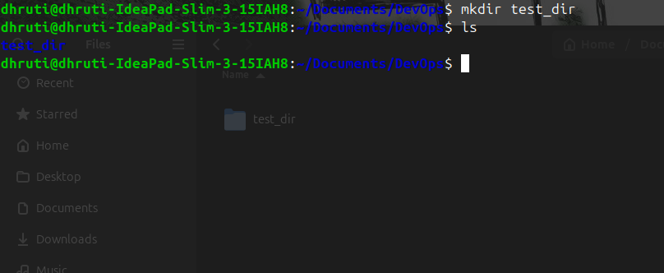

- Inside test_dir, create an empty file called example.txt.

touch test_dir/example.txt - Create an empty file inside “test_dir”

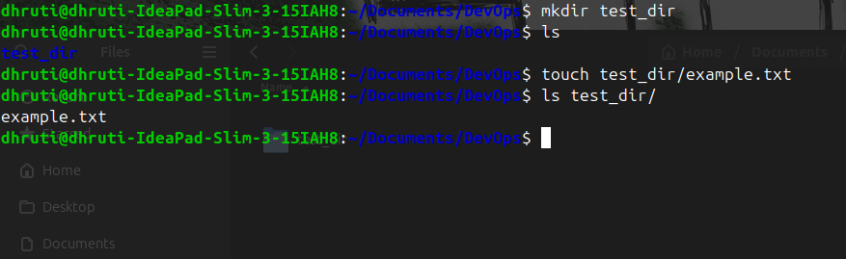

- Rename example.txt to renamed_example.txt using mv

mv test_dir/example.txt test_dir/rename_example.txt - mv is used to rename the file
from example.txt to rename_example.txt

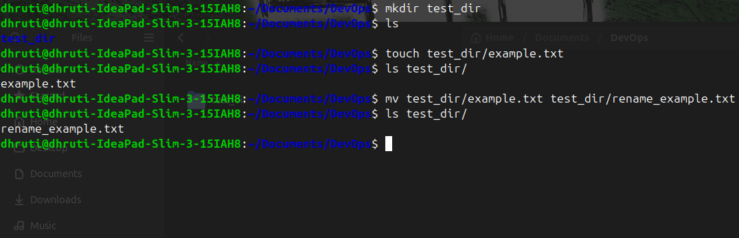

2. Viewing File Contents
- Use cat to display the contents of /etc/passwd.

cat /etc/passwd - Displays the entire contents of the file /etc/passwd

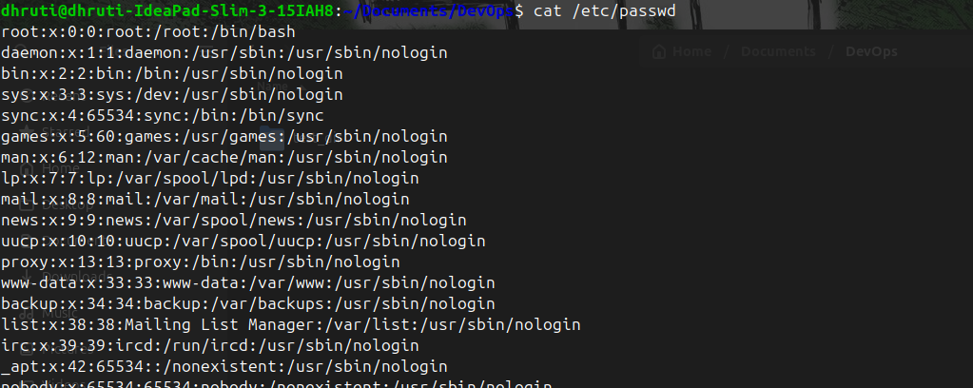

- Display only the first 5 lines of /etc/passwd using head.

head -n 5 /etc/passwd - Displays the first 5 lines of /etc/passwd

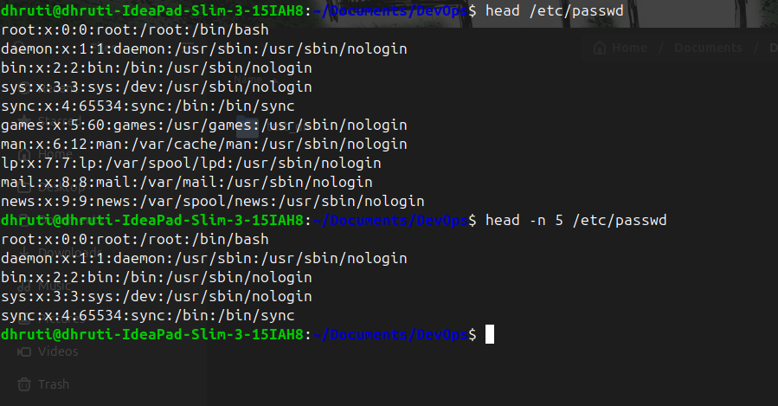

- Display only the last 5 lines of /etc/passwd using tail.

head -n 5 /etc/passwd - Displays the first 5 lines of /etc/passwd

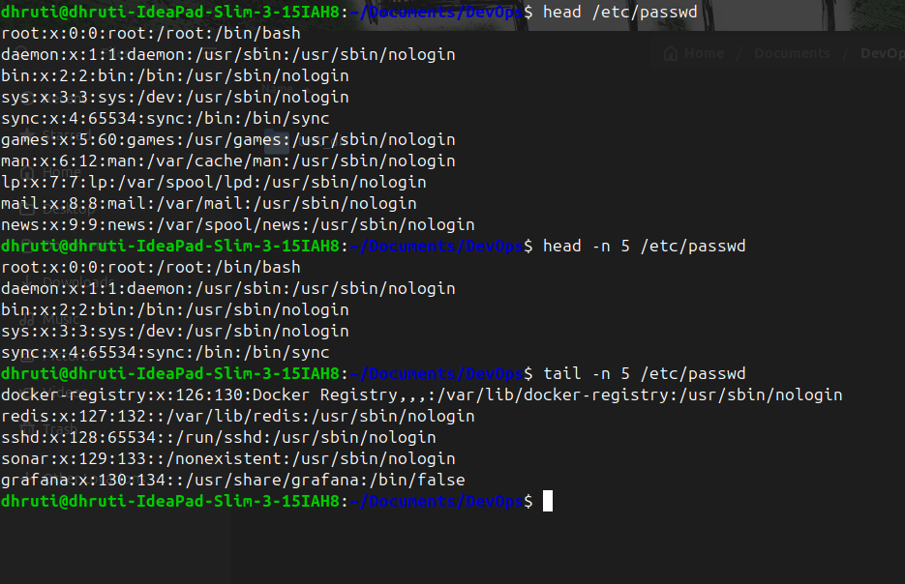
3. Searching for Patterns
- Use grep to find all lines containing the word "root" in /etc/passwd.

grep 'root' /etc/passwd - Searches for the keyword root in /etc/passwd and displays all lines containing it.
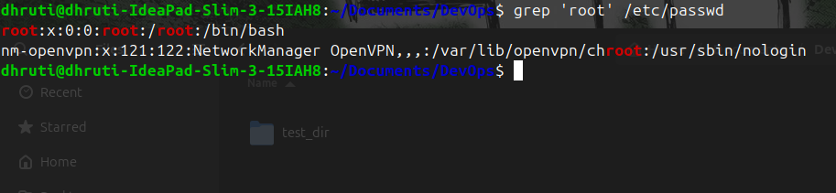

4. Zipping and Unzipping
- Compress the test_dir directory into a file named test_dir.zip using zip.

zip -r test_dir.zip test_dir - Compresses the entire test_dir directory into a zip file called test_dir.zip.
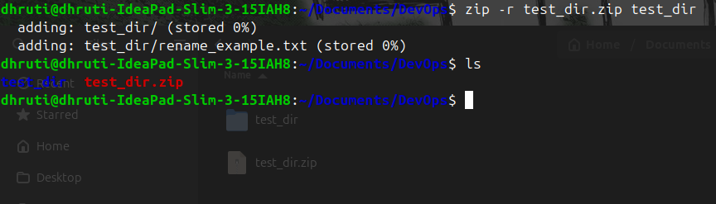

- Unzip test_dir.zip into a new directory named unzipped_dir.

unzip test_dir.zip -d unzipped_dir - Unzip the contents of test_dir.zip into unzipped_dir
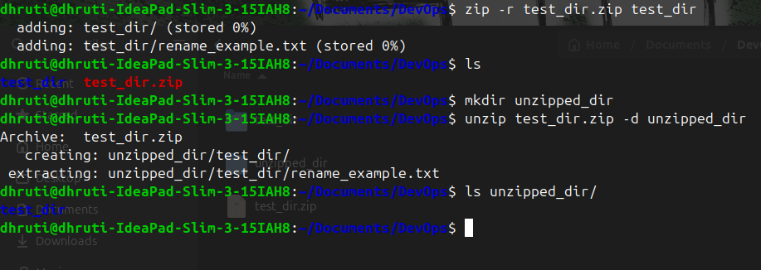
5. Downloading Files
- Use wget to download a file from a URL (e.g., https://example.com/sample.txt).

wget https://example.com - wget is used to download index.html from https://example.com

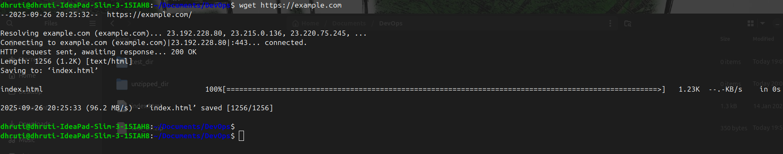

6. Changing Permissions
- Create a file named secure.txt and change its permissions to read-only for everyone using chmod.

chmod 444 secure.txt - Changes the permissions of the file to read-only for all users

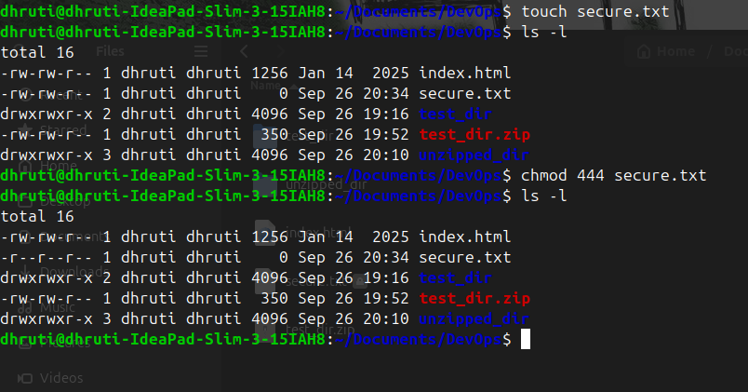

7. Working with Environment Variables
- Use export to set a new environment variable called MY_VAR with the value "Hello, Linux!".

export MY_VAR="Hello, Linux!" - Sets a new environment variable MY_VAR with the value “Hello, Linux”

